***SCREENSHOT OF THE***

***APPLICATION***

***Android icon***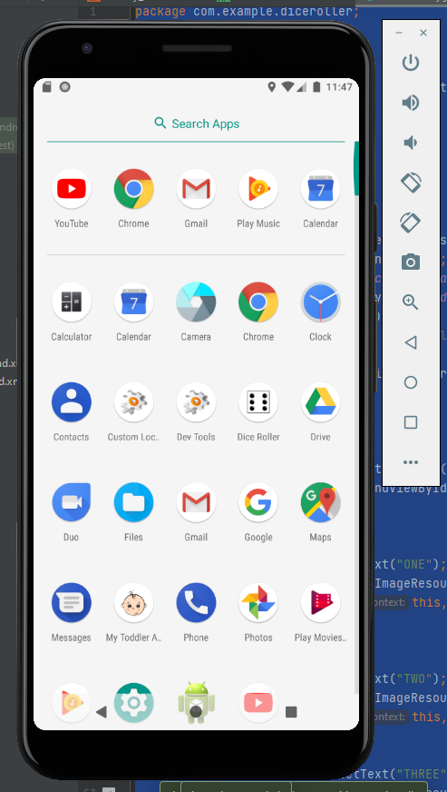

***Main***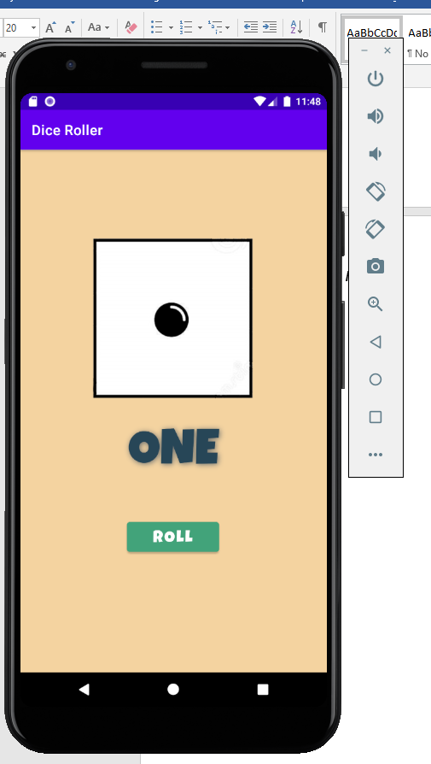

***Dice Rolled***